***Bash Scripting.***

1. **For loop Scripts:**

* Create a directory with name “Scripting” to store all the scripting files at a single location, for easy to access and availability
* Create a scripting file with the extension.sh
* Create a for loop script.

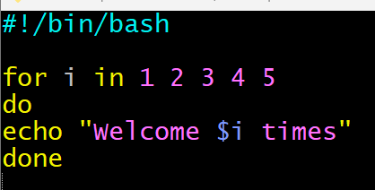

* Change the file permission for execution, change the permission to 755

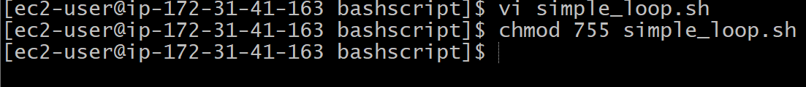

* Execute the file by keyword = ./

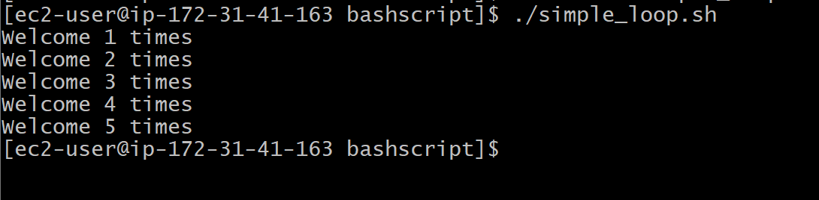

1. **Simple For loop output:**

* Create a scripting file with the extension.sh
* Create a for loop script.



* Change the file permission for execution, change the permission to 755

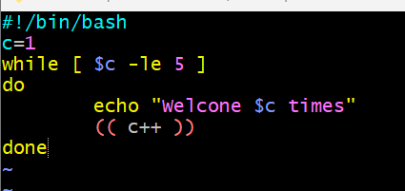

* Execute the file by keyword = ./

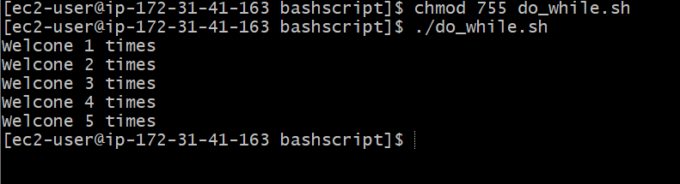

1. **Script to run for a number of seconds:**

* Create a scripting file with the extension.sh
* Create a for loop script.

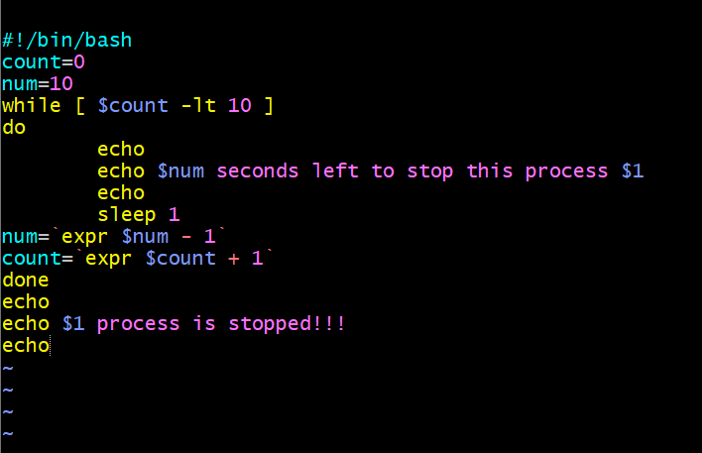

* Change the file permission for execution, change the permission to 755



* Execute the file by keyword = ./

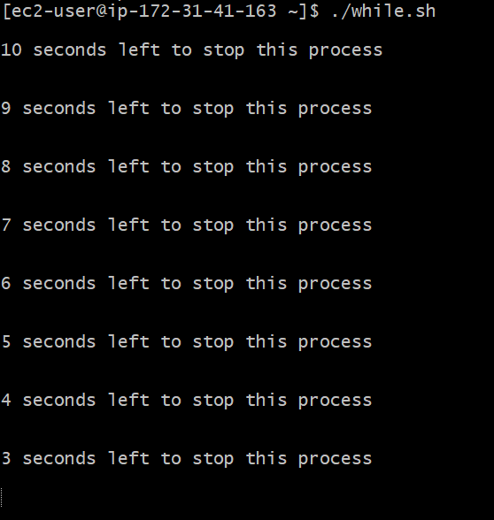

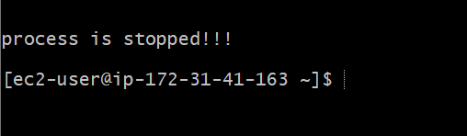

1. **If -then Script:**

* Create a scripting file with the extension.sh
* Create a for loop script.

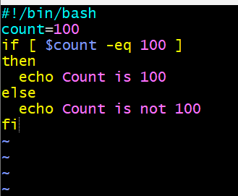

* Change the file permission for execution, change the permission to 755



* Execute the file by keyword = ./

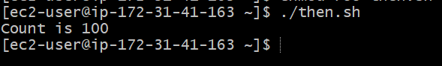

1. **Check if a file error.txt exist:**

* Create a scripting file with the extension.sh
* Create a for loop script.

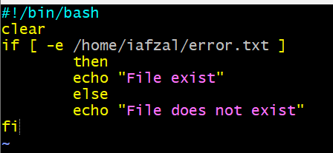

* Change the file permission for execution, change the permission to 755



* Execute the file by keyword = ./

